Student Name: Sahil Gupta UID: 25MCI10266
Branch: MCA(AI/ML) Section/Group: 25MAM-1 A
Semester: 2nd sem Date of Performance:12/01/2026
Subject Name: TECHINCAL SKILLS Subject Code:

WORKSHEET 6
AIM: Learn how to create, query, and manage views in SQL to simplify database queries and provide a layer of abstraction for end-users.

S/W Requirement: Oracle Database Express Edition and pgAdmin
OBJECTIVES:
- Data Abstraction: To understand how to hide complex table joins and calculations behind a simple virtual table interface.
- Enhanced Security: To learn how to restrict user access to sensitive columns by providing views instead of direct table access.
- Query Simplification: To master the creation of views that pre-join multiple tables, making reporting easier for non-technical users.
- View Management: To understand the syntax for creating, altering, and dropping views, as well as the naming conventions required for efficient data access.
Practical / Experiment Steps
Table creation:
CREATE TABLE Department (
dept_id SERIAL PRIMARY KEY,
dept_name VARCHAR(50)
);

Create table employee(
Emp_id serial primary key,
Emp_name varchar (50),
Salary numeric(10,2),
Status varchar(20),
Dept_id int references department(dept_id)
);

INSERT INTO Department (dept_name) VALUES
('HR'),
('IT'),
('Finance'),
('Sales');

Insert into employee(emp_name, salary, status, dept_id) values
(‘Kundan’,40000,’Active’, 1),
(‘Ranjan’, 10000,’Inactive’,2),
(‘Sahil’, 43000,’Active’, 2),
(‘Ram’, 25000,’Active’,3),
(‘Laxmi’, 60000, ‘Active’, 4);

Output:
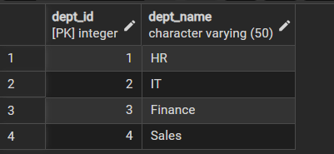
Employee table :
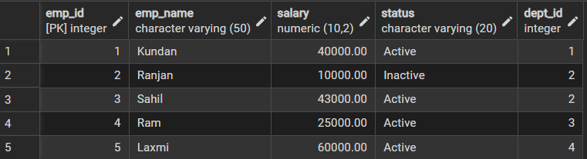
Step 1: Creating a Simple View for Data Filtering
- Implementing a view to provide a quick list of active employees without exposing the entire table structure.
CREATE VIEW Active_Employees AS
SELECT emp_id, emp_name, salary, dept_id
FROM Employee
WHERE status = 'Active';
Output:
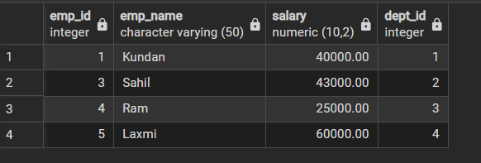
Step 2: Creating a View for Joining Multiple Tables
- Simplifying the retrieval of data distributed across Employees and Departments tables.
CREATE VIEW Employee_Department_View AS
SELECT
e.emp_id,
e.emp_name,
e.salary,
e.status,
d.dept_name
FROM Employee e
JOIN Department d
ON e.dept_id = d.dept_id;

Output:
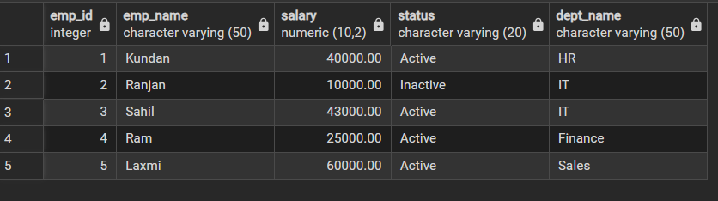

Step 3: Advanced Summarization View
- Creating a view to provide department-level statistics automatically
CREATE VIEW Department_Salary_Summary AS
SELECT
d.dept_id,
d.dept_name,
COUNT(e.emp_id) AS total_employees,
COUNT(CASE WHEN e.status = 'Active' THEN 1 END) AS active_employees,
SUM(e.salary) AS total_salary,
AVG(e.salary) AS avg_salary,
MAX(e.salary) AS highest_salary,
MIN(e.salary) AS lowest_salary
FROM Department d
LEFT JOIN Employee e
ON d.dept_id = e.dept_id
GROUP BY d.dept_id, d.dept_name;
Output:
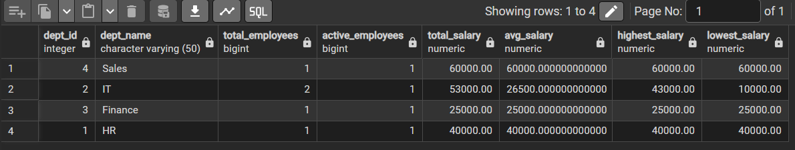

Outcomes:
- Abstraction Proficiency: Students will be able to create and query views to simplify efficient data access and abstraction.
- Security Implementation: Students will understand how to use views for data masking and providing restricted access to sensitive information.
- Syntactic Accuracy: Students will demonstrate the correct syntax for creating and querying views, ensuring logical clarity in naming conventions.
- Real-world Application: Students will be able to design views for practical domains like Library Management Systems or Payroll Systems to demonstrate functionality.

